Dr. Alexandria Connally
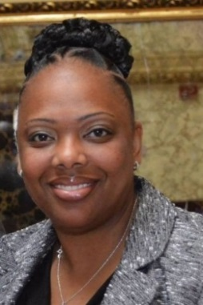
Dr. Alexandria Connally has dedicated herself to empowering students and improving the quality of education for all children. She began her career as a milieu therapist at a residential treatment facility. During this time, she provided professional development for faculty members in the areas of Therapeutic Crisis Interventions, Sanctuary Schools – A Trauma Informed Model, Restorative Practices, Athletic Based Counselling, and Positive Behavioral Interventions and Supports. She continued as a special education teacher. Later, Alexandria became the assistant principal of a residential school and in a public-school district in New York. Currently, she serves as the Inaugural Director of Equity, Inclusion, and Innovation of the Nyack School District. Dr. Connally is the first to hold the position of Chief Equity Director in any school district within Rockland County. Alexandria has devoted her professional life to ensuring equity in education.
Currently, Dr. Connally serves as the assistant to Regent Francis Wills. Formally, she was the assistant to Regent Judith Johnson, former Assistant Secretary of Education of Elementary and Secondary during the Clinton Administration. In her role Alexandria helped to shape the New York State Department of Education’s Committee on Equity, Integration, and Diversity. Alexandria also served as the Youth Voices Advocacy Program facilitator to the New York State Board of Regents Chancellor, Dr. Betty Rosa. Dr. Connally was a leader of the Yonkers My Brother’s Keeper Initiative. Under her direction, the program has received state and national recognition.
Dr. Connally is an advocate for strong communities and many different capacities. She was appointed to the Westchester County Youth Board. Alexandria currently serves on the Yonkers City Council President’s Special Education Advisory Board as well as the Pace University’s Transformative Leadership Program Board. Additionally, Dr. Connally serves as the co-chair of Sister-to-Sister International’s, Black Woman’s Girl Child, Juvenile Justice/ Suspension Committee. She is also a proud member of The Westchester County (NY) Chapter of The Links, Incorporated.
Dr. Connally is the founder and CEO of Culturally Responsive Environments and Discipline (C.R.E.A.D.). Trained by Dr. Bryant Marks, Alexandria serves as an implicit bias consultant for NTIRE. Additionally, she is a certified restorative practice trainer and has expertise in culturally responsive pedagogy.
In August 2018, Dr. Alexandria Connally successfully defended her dissertation entitled, “In Pursuit of Equity: Does the Implementation of Culturally Responsive Positive Behavioral Interventions and Supports Have an Effect on the Racial Suspension Gap?”

